Assignment two for kernel module

1. Check how many cores do you have using top command ?
- 4 cores
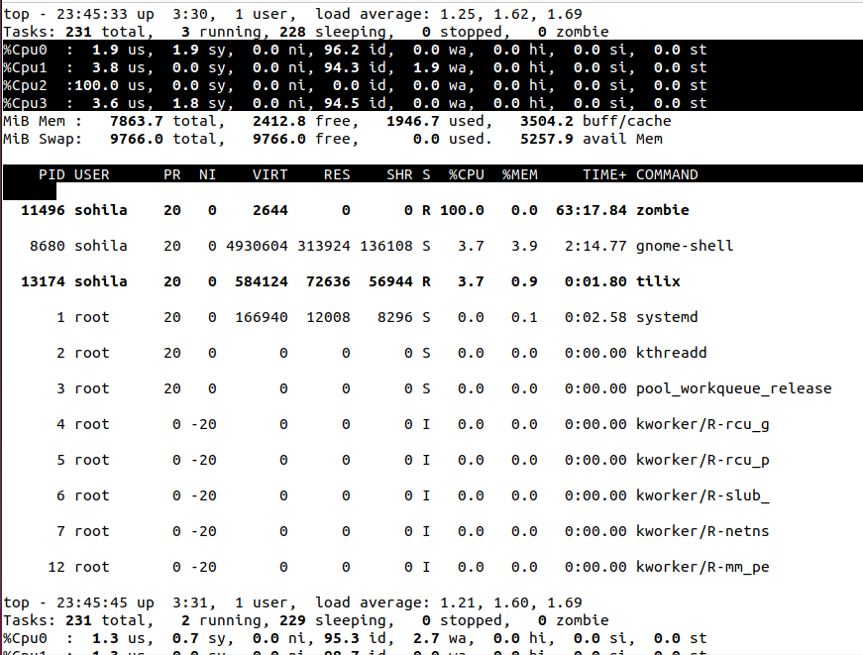

2. Create number of cores + 2 processes dd if=/dev/zero of=/dev/null run in background.
3. Change priority for them:
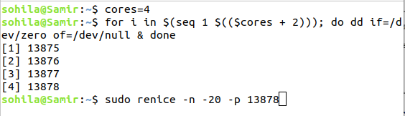
- -20, -10, 0, .. , 19
4. Monitor them using top command, did you notice any change ?
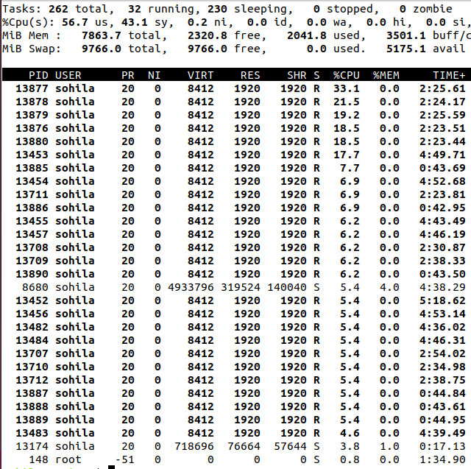
processes with lower nice values (higher priority) will likely use more CPU resources than those with higher nice values (lower priority).

5. Kill them all using killall command.
